

Practices for Secure Software Report

Table of Contents
Document Revision History 3
Client 3
Instructions 3
Developer 4
1. Algorithm Cipher 4
2. Certificate Generation 4
3. Deploy Cipher 4
4. Secure Communications 4
5. Secondary Testing 4
6. Functional Testing 4
7. Summary 4
8. Industry Standard Best Practices 4

Document Revision History

Version | Date | Author | Comments
1.0 | [2/22/2026] | [Jairo Figueroa Rojas] | Completed sections 1 through 8

Client



Instructions

Submit this completed practices for secure software report. Replace the bracketed text with the relevant information. You must document your process for writing secure communications and refactoring code that complies with software security testing protocols.

- Respond to the steps outlined below and include your findings.
- Respond using your own words. You may also choose to include images or supporting materials. If you include them, make certain to insert them in all the relevant locations in the document.
- Refer to the Project Two Guidelines and Rubric for more detailed instructions about each section of the template.

Developer
[Jairo Figueroa Rojas]

Algorithm Cipher

[In the Artemis Financial application, I implemented secure communication through the use of Transport Layer Security (TLS). Therefore, I used the Advanced Encryption Standard (AES-256) because it is highly recommended for encryption by the National Institute of Standards and Technology (NIST). Also, AES is excellent for securing the Artemis Financial application system because it is a symmetric encryption algorithm, which means that the same key can be used for both encryption and decryption, and its 256-bit key provides significant protection against cyberattacks. Moreover, the SHA-256 hashing algorithm is used to generate a checksum for data verification, producing a 256-bit hash value that helps detect any changes to the data. Additionally, TLS utilizes asymmetric encryption to safely exchange keys during the initial handshake, while random number generation is used to create secure keys and prevent attacks. Furthermore, when comparing outdated algorithms like DES and SHA-1, they are no longer considered secure, so modern systems use AES and SHA-256 as they comply with current security standards. Hence, implementing HTTPS and SHA-256 is essential for Artemis Financial because it maintains secure communication, data integrity, and confidentiality.
]

Certificate Generation
Insert a screenshot below of the CER file.

[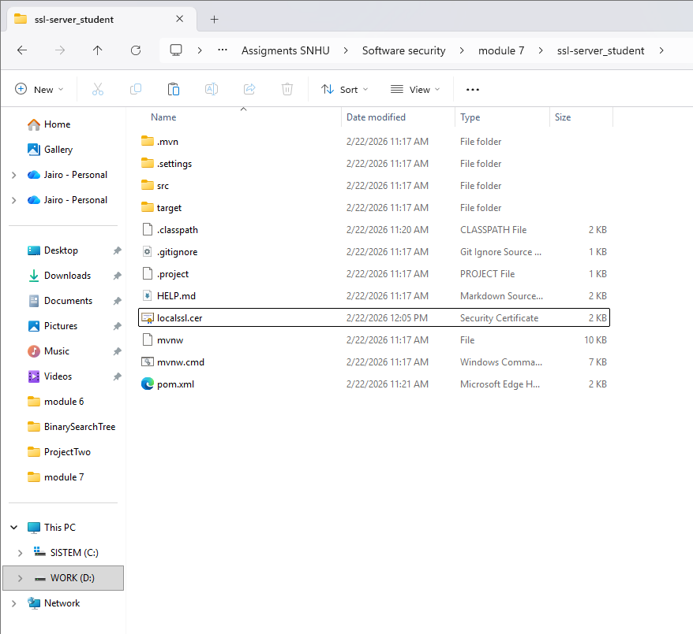]

Deploy Cipher
Insert a screenshot below of the checksum verification.

[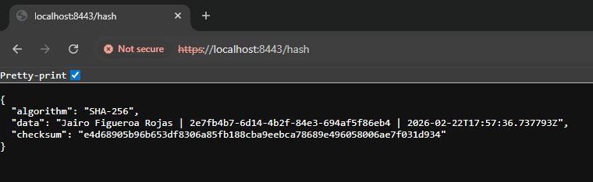]

Secure Communications
Insert a screenshot below of the web browser that shows a secure webpage.

[
]

Secondary Testing
Insert screenshots below of the refactored code executed without errors and the dependency-check report.

[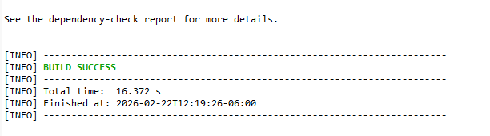
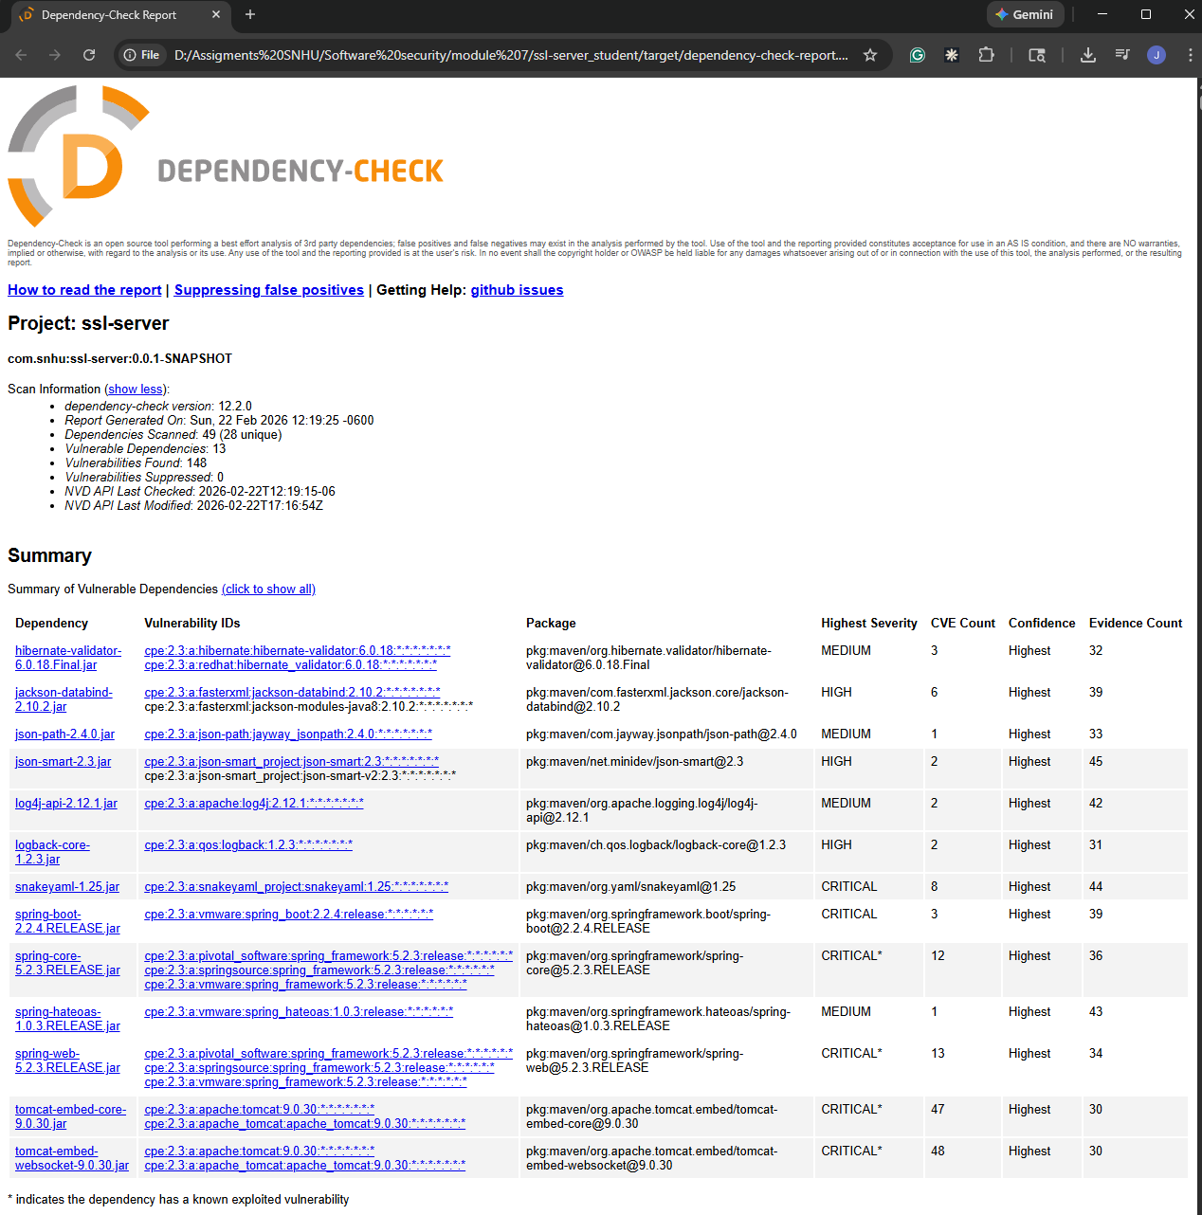]

Functional Testing
Insert a screenshot below of the refactored code executed without errors.

[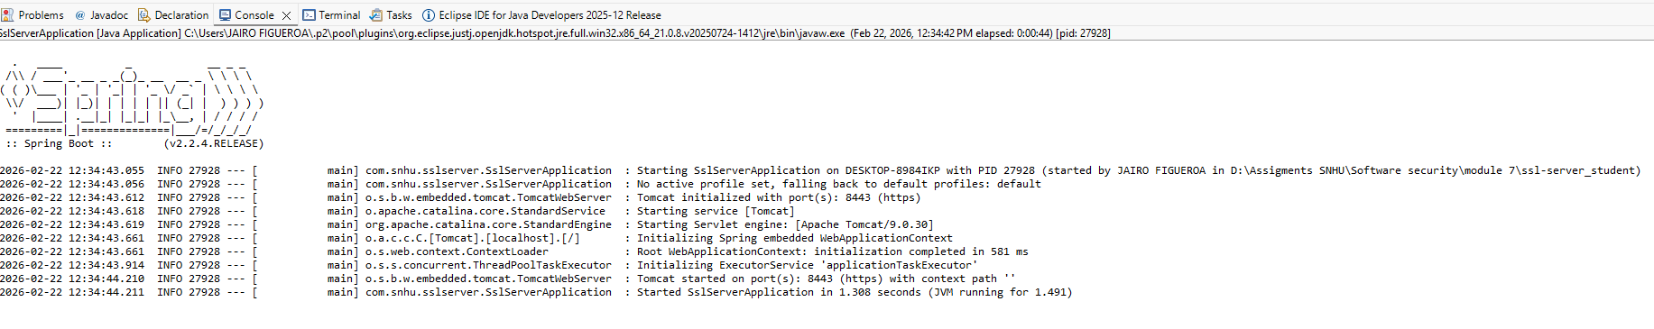
]

Summary

[In this project, I have refactored the code by following secure software development practices to enhance the safety and security of the Artemis Financial program. According to the vulnerability assessment, the areas that needed to be worked on were encryption, data integrity, and secure communication. So, to achieve this, I implemented HTTPS by utilizing Transport Layer Security (TLS) to secure data exchange and transfer, and to make it even stronger, a SHA-256 hashing algorithm was added to create a checksum for data verification. Also, I used the Java Keytool provided by the Eclipse IDE to generate a self-signed certificate to facilitate secure communication. Furthermore, I conducted static testing through the OWASP Dependency-Check tool to find any vulnerabilities and make sure that no new security threats were introduced by the refactored code. In conclusion, I used several security measures, such as hashing, encryption, and static testing, to ensure that the application is secure and complies with industry standards.
]

Industry Standard Best Practices

[In this project, I used industry standard best practices to ensure the security of the Artemis Financial application by minimizing possible vulnerabilities. So, I utilized HTTPS with TLS encryption to secure data transfer/exchange, and the SHA-256 hashing algorithm to verify data integrity, which ensures that no data changes have been made. Moreover, I used the OWASP Dependency-Check tool to perform static testing, which reveals any vulnerabilities that the program has and that may need to be fixed. These best practices help protect the application by securing critical data, thus avoiding any possible security attacks. Therefore, the company must use industry standard best practices as it helps minimize the risk of data breaches and ensures the application is secure and trustworthy.
]

